Final Project Report – US Election 2020 Sentiment Analysis

**Introduction:**

Forecasting the Presidential Elections has become a trend in Academia. Recently, US 2020 Elections were held, and the main contestants were Joe Biden from Democratic party and Donald Trump from Republican Party. I wanted to do Sentiment Analysis on Twitter data to get results of who will be the possible winner of US 2020 Elections.

**Problem Statement:**

1. Is Trump liked more or Biden?
2. Trump vs Biden Tweet count in India?
3. Trump or Biden, who has more positive tweets?

**Related Work:**

**Methods:**

Tools used -

I worked with Python Programming Language in IDE Google Colab. I used Pandas for Reading the Data set and also for Data Transformation, NumPy also for data Transformation. Matplotlib for Data Visualizations.

Load Data –

First, I loaded the Two data sets “Trump Data”, “Biden Data” into two different data frames.



Data Transformation –

I drop () function to drop few columns in the data set as they were not useful for my analysis.

I used loc [] method to get only the data of Trump in Trump Dataset and Biden in Biden Data set.

I used Concat () method to mix both the data frames into one data frame.

I used Sort_values () method to sort the data frame on the column “created_at” in ascending order.

Data Visualization –

Xtick () function is used in bar plot to keep labels in x axis. Here I used Xticks for labeling Donald Trump and Biden on x-axis.

Used Bar plot from Matplotlib for this.

Here, I used default blue color as we don’t have many variables to compare to.

Fig:

Tweets count of each candidate is visualized through pie chart. Here I defined a function to calculate the pie chart with input of country name.

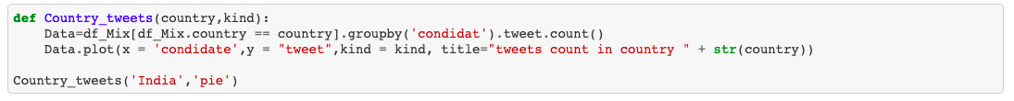

Orange and Blue colors differentiate each candidate in pie chart.

Data Cleaning -

In order to do Sentiment Analysis, we have to remove the noise in the tweets like punctuation, numbers, stop words, spaces and convert them to lower case.

Dropped the Null Values using function dropna ()

Sentiment Analysis:

I have created functions to calculate the subjectivity score, polarity score and analysis based on score to find the sentiment of the tweets.

Here I had used NLTK, TextBlob Libraries for finding the scores.

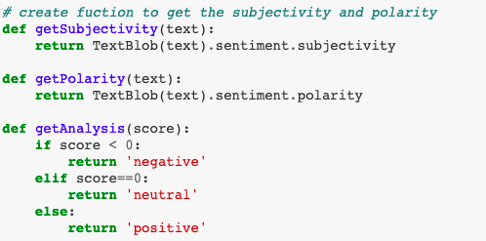

Imported Counter from Collections library to count the values of each sentiment positive, negative and neutral.

I imported graph_objects from plotly library to make a funnel area chart.

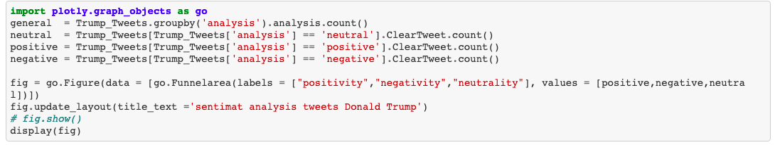

Funnel Area is used to show data in different stages.

Fig:

Fig:

We can clearly see from the chart that Trump has 39.8%, Joe Biden has 45.5% positive tweets.

**Results:**

From the sentiment analysis, we found out that Joe Biden has more chance of winning the US 2020 Election even though the data had more likes for Donald Trump.

**Discussion:**

From the Visualizations people can infer that Donald Trump has more likes than his counterpart from the bar chart. The Pie chart tells that In India, there was more discussion about Joe Biden than Donald Trump. From Sentiment Analysis, through funnel area graph chart we found that Donald Trump has fewer positive sentiments and more negative sentiments in the tweets than Joe Biden.

**Future Work:**

**References:**

* 1. <https://medium.com/swlh/data-visualization-us-election-2020-a3d3531b611c>